Software Requirements Specification
for
FINALyze
Version 1.0 approved
Prepared by
Mohammed Aiman Khan
VIT
22-01-25
Table of Contents
Table of Contents ii
Revision History ii
1. Introduction 1
1.1 Purpose 1
1.2 Document Conventions 1
1.3 Intended Audience and Reading Suggestions 1
1.4 Product Scope 1
1.5 References 1
2. Overall Description 2
2.1 Product Perspective 2
2.2 Product Functions 2
2.3 User Classes and Characteristics 2
2.4 Operating Environment 2
2.5 Design and Implementation Constraints 2
2.6 User Documentation 2
2.7 Assumptions and Dependencies 3
3. External Interface Requirements 3
3.1 User Interfaces 3
3.2 Hardware Interfaces 3
3.3 Software Interfaces 3
3.4 Communications Interfaces 3
4. System Features 4
4.1 System Feature 1 4
4.2 System Feature 2 (and so on) 4
5. Other Nonfunctional Requirements 4
5.1 Performance Requirements 4
5.2 Safety Requirements 5
5.3 Security Requirements 5
5.4 Software Quality Attributes 5
5.5 Business Rules 5
6. Other Requirements 5
Appendix A: Glossary 5
Appendix B: Analysis Models 5
Appendix C: To Be Determined List 6

Revision History
Name | Date | Reason For Changes | Version
Mohammed Aiman Khan | 22-01-25 | New | 1.0

Introduction

Purpose
To create a user specific web app which calculate
- gross & net margin for product and
- analyzes the Return on Investment for user for each product.

Document Conventions
Higher priorities represented in bold and red color.

Intended Audience and Reading Suggestions
This document is intended for developers, project managers, customer representatives, users, testers, and documentation writers.

Product Scope
Business community can use the web application FINALyze to understand how each product in their business is contributing to the overall business. This can be done by calculating the gross and net margins and ROI at product level.
With the information accessed from FINALyze Business owners can analyze the reports and take corrective/preventive actions for business improvement or they can boost further for growth or if the margins and ROI is as per the expectations the current process can be tracked and carried.

This application provides insight of business performance at product level and helps for business decisions.

References
- Business calculation sheet
- Business requirement Sheet
- Basic layout sheet

Overall Description

Product Perspective 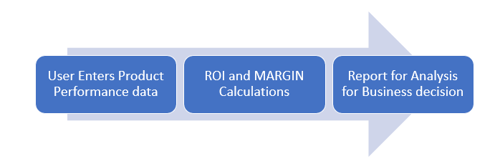
This app can be furthered enhanced to get the business perspective at various sub-divisions and at the organization level as well.

Product Functions
- AUTHORIZATION:
  - New User Registration
  - Existing user sign-in
  - Existing user
- PRODUCT PERFORMANCE DATA ENTRY
  - Enter the product related details
  - Enter product sale performance details
  - Enter product expense details
  - Enter business investment at product level
- CALCULLATION
  - Gross margin
  - Net margin
  - ROI
- REPORT
  - Product performance report.>

User Classes and Characteristics
1: Administrator: Has all the rights for the app.
2: End User: Has access rights for login, logout, data entry.
3: Product in charge: Has access to product data, calculations and report
4: Technical team: Will have access to the source code
5: Testing team: Web App frontend

Operating Environment
- MS Windows 10/11
- Intel i3+
- RAM 8MB
- Hard disk 10GB
- Visual Studio
- <<Framework details to be filled after finalization>>

Design and Implementation Constraints
- Framework Identification and Skill are the major constraints
- Time constraint as the semester is small hence challenging timelines

User Documentation
- User Guide
- Implementation Documentations

Assumptions and Dependencies
- Assume a widely used MVC framework will be selected as skill and resources are freely available
- Development will be done on local host and no hosting is in scope
- Master data of product and business is not taken into scope
- Scalability and Security are not in scope
- Dependency is on framework finalization.

External Interface Requirements

User Interfaces
USER Registration
User_name
Password
Confirm_Password
SAVE | CANCEL

LOGIN
User_name
Password
SAVE | CANCEL

Product
Product_code
Product_desc
SAVE | CANCEL

SKU
Product_code
SKU_Code
SKU_Name
SKU_Land_Pric
SKU_Sell_Pric
Pack_Qty (kg)
SAVE | CANCEL

Monthly Net Profit
Product_code
Month_year
Expenses
SKU_Name | No. of Bags | Passing On Scheme value (Rs.) | Incetive (Rs.)
Calcullate | CANCEL
Net Profit

ROI - Month
Product_code
Month_year
STOCK In STORAGE
SKU_Name | No. of Bags | QTY
STOCK In Market
SKU_Name | No. of Bags | QTY
INVESTMENT
SKU_Name | Sales(Rs.) | Stock_in_hand(Rs.)
Calcullate | CANCEL
Rotation %
Net Margin
ROI

Hardware Interfaces
<Not Applicable.>

Software Interfaces
<Not Applicable.>

Communications Interfaces
<Not Applicable.>

System Features

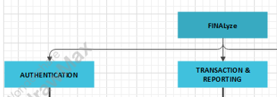

AUTHENTICATION
4.1.1 Description and Priority
This is a mandate functionality to maintain data security
4.1.2 Stimulus/Response Sequences
When new user or existing user wants to login
Or logged user needs to exit out of the app.
4.1.3 Functional Requirements
User Registration
User Login
User Logout

TRANSACTION and REPORTING
4.2.1 Description and Priority
This is a mandate functionality for the web app. This is the heart of the app.
4.2.2 Stimulus/Response Sequences
When user wants to know the performance of product
4.2.3 Functional Requirements
- Entry screen for product performance data
- Margin Calculations
- ROI calculations
- Reporting

Other Nonfunctional Requirements

Performance Requirements
<Not in scope.>

Safety Requirements
<Not in scope.>

Security Requirements
- User based security

Software Quality Attributes
Product should pass the user acceptance test cases.

Business Rules
1: Administrator: Manage the app and to ensure it is up and running.
2: End User: Works on App.
3: Product in charge: Ensure the app is utilized as intended
4: Technical team: To be available to support the app after released to customer and to develop the app
5: Testing team: to work along technical team

Other Requirements
<None.>
Appendix A: Glossary
H/W – Hardware
S/W – Software

Appendix B: Analysis Models
Appendix C: To Be Determined List
- Framework related details to be added

